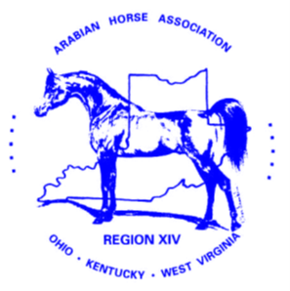

December 31, 2021
Greetings Region 14 members!
The past two years have been a challenge for most of us and as we look ahead to 2022.
There has been much discussion, disagreement and decisions made at the upper levels of the Arabian Horse Association this past year mostly in response to said pandemic. The first is the return of the Qualification system for our shows. Whereas the previous system was one of points or placings, the new system is that of Participation. Because the availability of qualifying classes is not the same around the country the Competition Advisory Committee adjusted the qualifying system based on this situation. Different classes/disciplines fall under different Categories. Check those categories to see where your classes fall and become familiar with how you must qualify (or not). Here is a link to the new plan:
https://www.arabianhorses.org/export/content.export/aha-docs/AHA_Approved_Qualifications.pdf
Further information regarding qualifications and leveling can be found here:
https://www.arabianhorses.org/competition/resources/qualifications/
Another decision passed by the AHA BOD is the alternate Virtual/Live Convention plan. This will be a financial savings to AHA by only having In-Person convention every other year. The 2022 AHA Convention will be held in person at Myrtle Beach, SC Nov. 9-12. More information coming soon!
The latest decision by the AHA BOD was the permanent addition of the Midsummer National Show held in conjunction with Youth Nationals. This show was originally created to help manage the cancellation of Canadian Nationals. Because the show proved to be financially successful, it was determined that it should remain a permanent addition to the AHA Calendar. More information regarding this show will be coming from the Commission.
Regarding the Calendar, many regional shows have had to adjust their traditional dates. Make sure you check the AHA Calendar if you plan to attend these competitions as their dates and locations may have changed!
The Region 14 Championship will be held August 17-21, 2022, at the World Equestrian Center in Wilmington, OH.
At our 2022 August meeting, our election will be held for the next term of the Region 14 Officers. If you have any interest in running for a position, please contact the nominating committee chair (after their appointment) which will be announced at our January meeting and the chair will explain the positions and the responsibilities of each.
As always, if you have concerns, questions, or comments, please reach out to your club delegates or to one of the Region 14 Board members. You can also reach me directly at jcaldwell2995@yahoo.com anytime! As we begin 2022, I wish you all health, blessings, and more time to spend with our wonderful Arabian horses!
Respectfully,
Jeff Caldwell
Director Region 14

